**Assignment 1(B)**

**PART 1: Data description**

To indicate a particular neighbourhood is undergoing gentrification is to compare with both non-gentrifying and completely gentrified neighbourhoods as benchmarks. This study compared those neighbourhoods’ changes in percentages with percentage changes at South Australia state level.

Using ABS census data, key indicators that neighbourhood might undergo early gentrification:

1. *decrease in percentage of people aged 18 years and under*,
2. *increase in percentage of females* *and increase in percentage of professional workers*,
3. *increase in percentage of total household income above $3000*, and
4. *increase in percentage of people completed tertiary education*.

For this early investigation, three neighbourhoods were chosen to study the neighbourhood features based on the indicators above. These suburbs include a gentrifying suburb, Torrensville, a non-gentrifying suburb, Brooklyn Park and a suburb that has already gentrified, Unley.

Based on Figure 1, all indicators have approximately a normal distribution, but few might undergo log transformation to produce a Gaussian distribution, such as house_2021 and seifa_score_2021.

Figure 1: Overall indicators distribution

**PART 2 & 3: Clustering/Pattern and Visualization**

**Decrease in percentage of people aged 18 years and under**

Table 1: Comparison neighbourhoods of 18 years and under

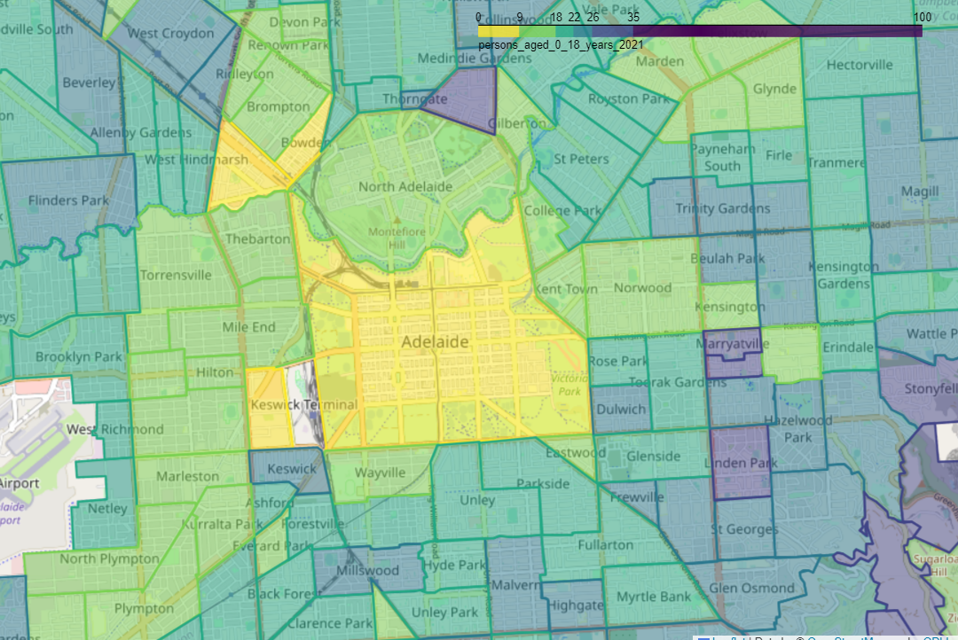

Figure 2: Distribution of 18 years and under in Adelaide for 2021 census.

Table 1 indicates overall neighbourhoods had a decreasing trend between 2016 to 2021 and this is comparable to the state average. Torrensville shows the highest percentage of falls, registered at 2.6% above state average. According to Kolko, percentage of children under 18 years falls is an early sign of gentrifying neighbourhood (Kolko 2007, p.25). Figure 1 shows the West part of Adelaide neighbourhoods might experience similar conditions to Torrensville. In the South area, most neighbourhoods experienced a similar situation to Unley, where the percentage of children under 18 years keeps declining. Figure 1 indicates that West of Adelaide potentially has bigger family households compared to South of Adelaide.

**Increase in percentage of female and professional’s and percentage of professional’s worker.**

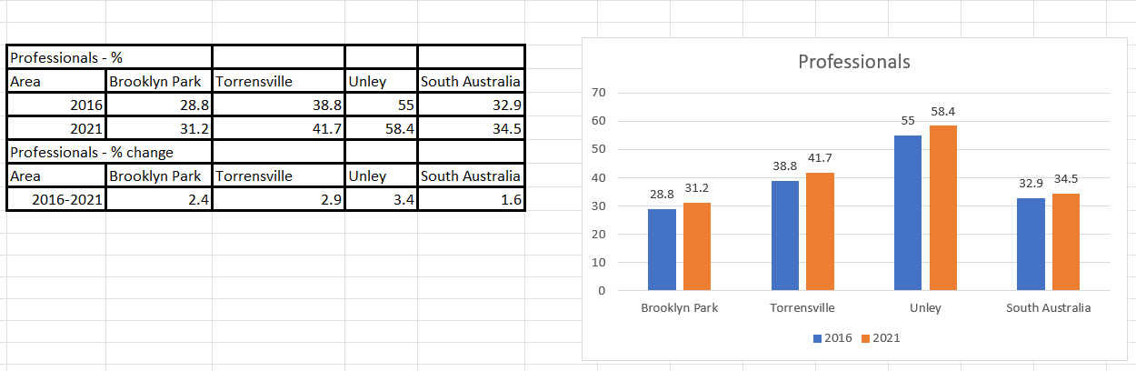

Table 2: Comparison of Professionals

Table 3: Female's Professionals

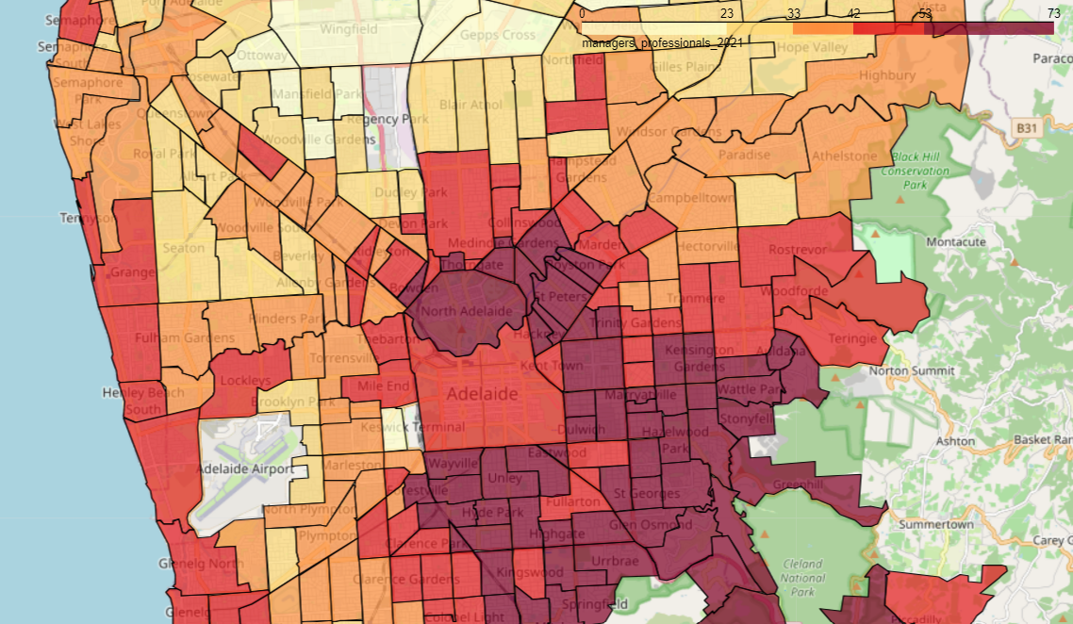

Figure 3: Distribution of Professionals in Adelaide for 2021 census.

Table 2 shows Unley neighbourhood measuring the highest percentage registered at 3.4%. Similar pattern to Figure 3, in the South part of Adelaide, many neighbourhoods have a higher percentage of professional workers because generally they have high incomes based on Figure 5. Signs of gentrifying can be seen in Torrensville during 2021, recorded at 41.7% above state average. An increase in percentage of female professional workers could indicate that neighbourhood is gentrified. Table 3 implies Torrensville has the highest percentage changes, registered at 2.5%. These findings are consistent with Baker’s study where she found that an increasing number of females (pursuing professional careers) indicating that females are amongst the gentrifiers (Baker 1997, p. 8).

**Completed tertiary education.**

Table 4: Comparison in completed tertiary education.

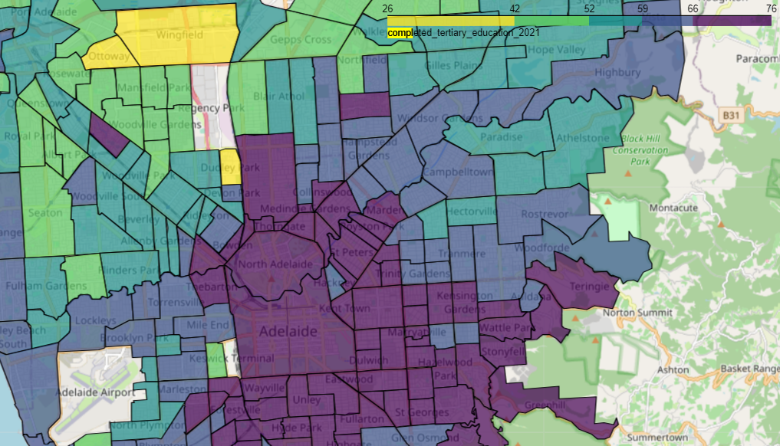

Figure 4: Distribution of completed tertiary education in Adelaide for 2021 census.

Figure 4 displays similar distribution patterns as per Figure 3, where most of the South and South-East areas have a higher population who have completed tertiary education and potentially have professional occupations. Table 4 shows Torrensville has a percentage registered at 4.7% above state average. This shows that Torrensville is experiencing a gentrifying process, Brooklyn Park listed the highest percentage due to Adelaide College of Divinity (ACD) being established and a Youth Hostel was opened in 1999 to accommodate tertiary students.

**Increase in percentage of total household income more $3000.**

Table 5: Comparison in household income more than $3000.

Figure 5: Distribution of household income for more than $3000 in Adelaide for census 2021.

Table 5 implies Torrensville has the highest percentage change in household income, registered at 11% between 2016 to 2021. This potentially indicates an influx of higher income people entering Torrensville. Figure 4 shows similar patterns as per Figure 3 and Figure 4, where South of Adelaide has a population with income above $3000.

**PART 4 (A): Additional data**

Walking scores and social liveability index are collected to help with predicting the next neighbourhood to be gentrified besides using ABS data. The walking score provides information about the walkability, transit options, and bike ability of a given location. The walking score ranges from 0 to 100.

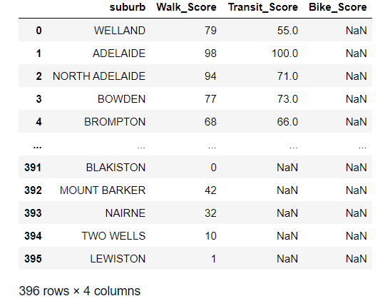

Figure 6: Walking Score

Next, social liveability index is measured in terms of social infrastructure such as culture and leisure, closest general practitioners and community and sport. These indexes can be extra dimensions of indicators for prediction.

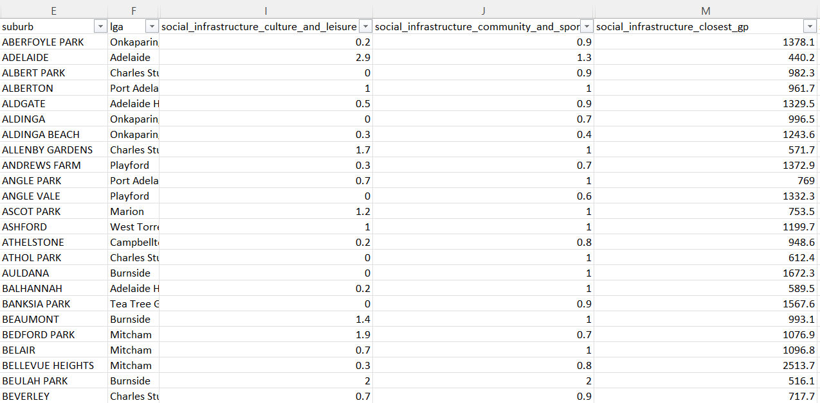

Figure 7: Social liveability index

**PART 4 (B): Problem refinement.**

By cooperating the changes in those 4 indicators with additional data, we can determine gentrification patterns observed in previous studies. Alas, it produces a more reliable classification system to predict and identify neighbourhoods undergoing or likely to undergo gentrification.

**References**

Badcock, B 2001, ‘Thirty years on: Gentrification and class changeover in Adelaide’s inner suburbs, 1966-96’, *Urban Studies (Edinburgh, Scotland)*, vol. 38, no. 9, pp. 1559–1572.

Baker, E 1997, ‘Gentrification and gender effects in North Adelaide’, Thesis (B.A.(Hons.)) --University of Adelaide, Dept. of Geography, 1998.

Kolko, J 2010, ‘The determinants of gentrification’*, SSRN Working paper Series*.

Loukaitou-Sideris, A, Gonzalez, S and Ong, P 2017. ‘Triangulating Neighborhood Knowledge to Understand Neighborhood Change: Methods to Study Gentrification’, *Journal of Planning Education and Research*, 39(2), pp.227–242, DOI:10.1177/0739456x17730890.

Zeng, J, Yue, Y, Gao, Q, Gu, Y & Ma, C 2022, ‘Identifying localized amenities for gentrification using a machine learning-based framework’, *Applied Geography (Sevenoaks)*, vol. 145, p. 102748–.

‌